**NAME:** Asjid Tahir

**CLASS:** BSCS   
**SECTION:** 2B2  
**ROLL NO:** 19P-0085  
**SEMESTER:** 02

**LAB TASKS: DLD**

**TOPIC:**

**Multiplexers & De-multiplexers**

**TASK # 01:**

**2 : 1 Multiplexers:**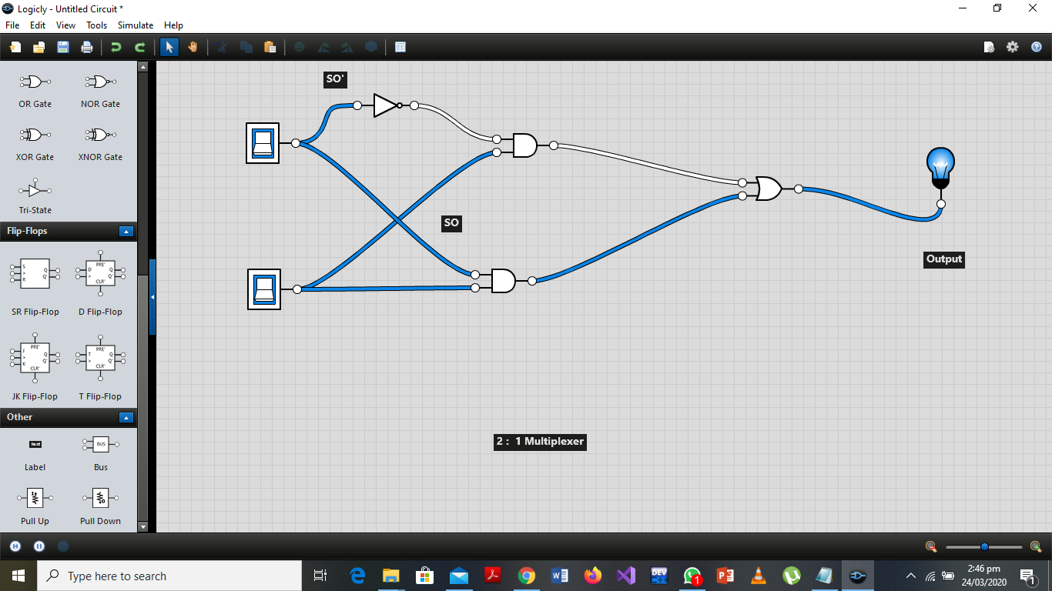

**TASK # 02:**

**4: 1 Multiplexers:**

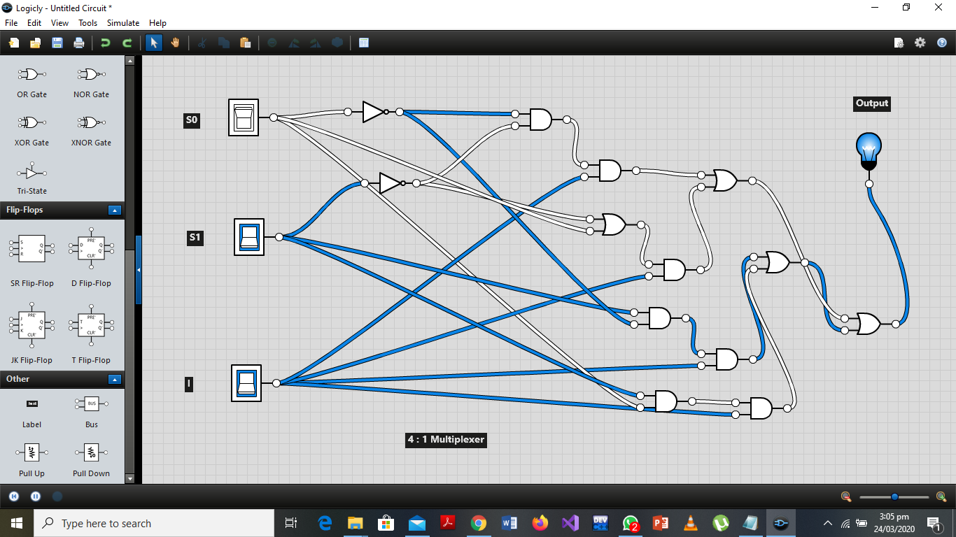

**TASK #03 :**

**8 : 1 Multiplexers**

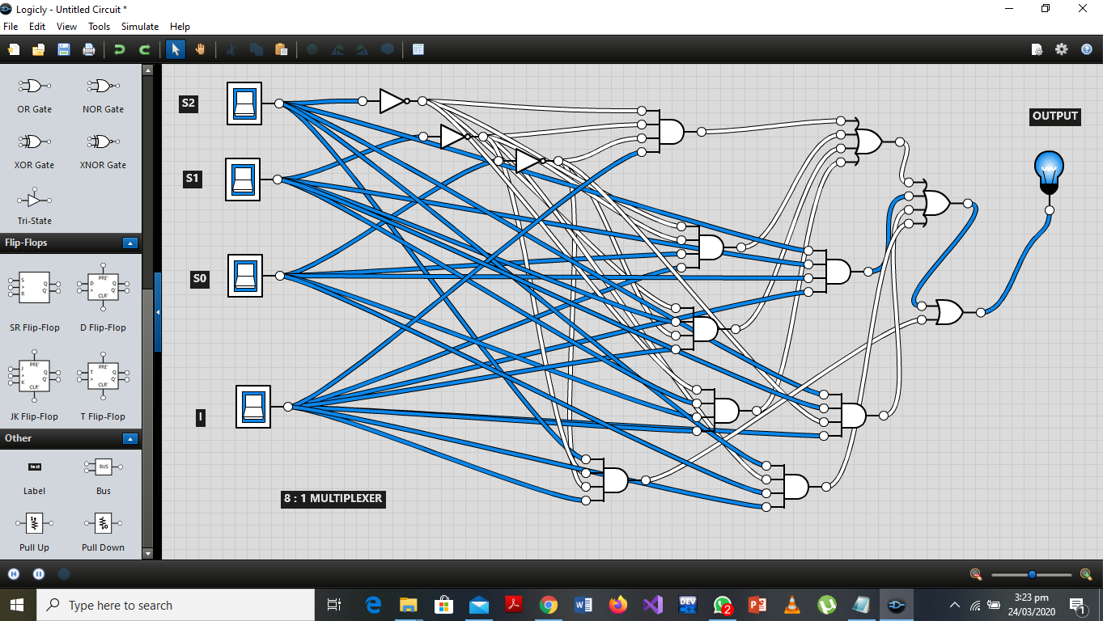

**TASk # 05:**

**Demultiplexers:**

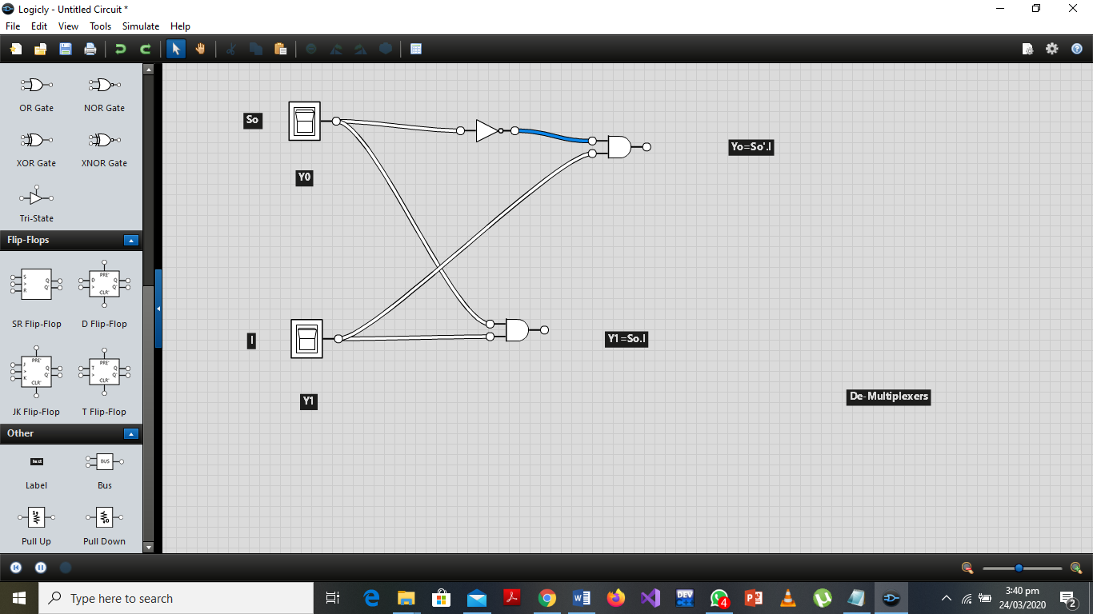

**TASK # 04:**

**Multiplexers by using 4 : 1 and 2 : 1:**

